HTML PROJECT1

Home.html:-
<html>
<head>
<style>
body{
background-color: yellowgreen;
color: aliceblue;
}
nav a{
background-color: aliceblue;
}
aside a{
color: red;
padding: 1px 5px;
}
aside a :hover{
background-color:pink;
color:brown;

}
header{
color: blueviolet;
}
footer{
background-color: beige;
color:red;
}
</style>
</head>
<center>
<body>
<header>
<h1>AI-DS</h1>
</header>
<nav>
<a href="total no.of students.html">total no.of students</a>
<a href="subject.html">subject</a>
<a href="faculty.html">faculty</a>
<a href="examsheet.html">examsheet</a>
<a href="login.html">login</a>
<a href="register.html">register</a>
</nav>
<section>
<article>
<p>Name is Kavyanjali</p>
<p>I am studying 3rd year AI-DS</p>
</article>
</section>
</center>
<aside>
<a href="about AI-DS.html">about AI-DS</a><br><br><br>
<a href="magazine.html">magazine</a><br><br><br>
<a href="training.html">training</a><br><br><br>
<a href="gallery.html">gallery</a><br><br><br>
</aside>
<footer>
<center>
<h1>Trained by THE GREAT VINOD SIR</h1>
</center>
</footer>
</body>
</html>

OUTPUT:-
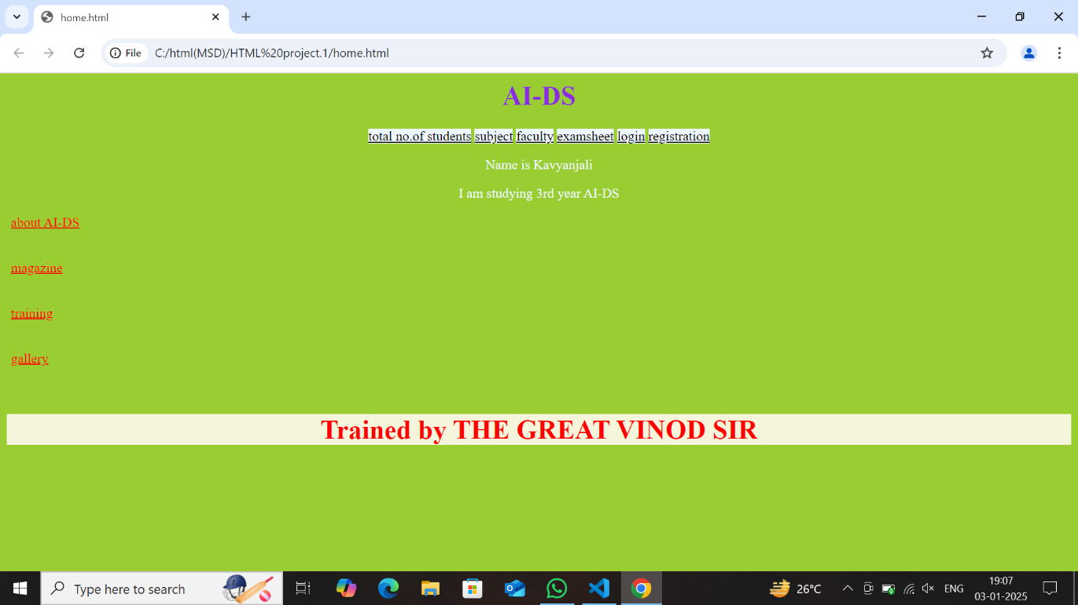

Total no.of students.html:-

<html>
<head>
<style>
body{
background-color: yellow;
color: red;
}
h1{
color: blue;
}
footer{
color: green;
}
</style>
</head>
<center>
<body>
<h1>AI-DS</h1>
<p>Artificial Intelligence and Data Science</p>
<h1>NO.OF STUDENTS=61</h1>
</center>
<footer>
<h1><marquee>Trained by Vinod Sir</marquee></h1>
</footer>
</body>
</html>
OUTPUT:-

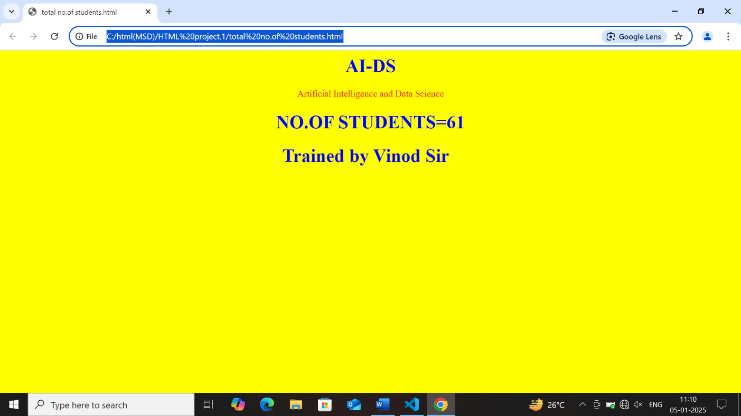

Subject.html:-

<html>
<head>
<style>
body{
background-color: skyblue;
}
h1{
color: pink;
}
</style>
</head>
<center>
<body>
<h1>MSD</h1>
<ol type="I" start="1">
<li>Unit-1</li>
<li>Unit-2</li>
<li>Unit=3</li>
<li>Unit-4</li>
</ol>
<h1>CN</h1>
<ol type="I" start="1">
<li>Unit-1</li>
<li>Unit-2</li>
<li>Unit=3</li>
<li>Unit-4</li>
</ol>
<h1>DL</h1>
<ol type="I" start="1">
<li>Unit-1</li>
<li>Unit-2</li>
<li>Unit=3</li>
<li>Unit-4</li>
</ol>
</body>
</center>
</html>

OUTPUT:-
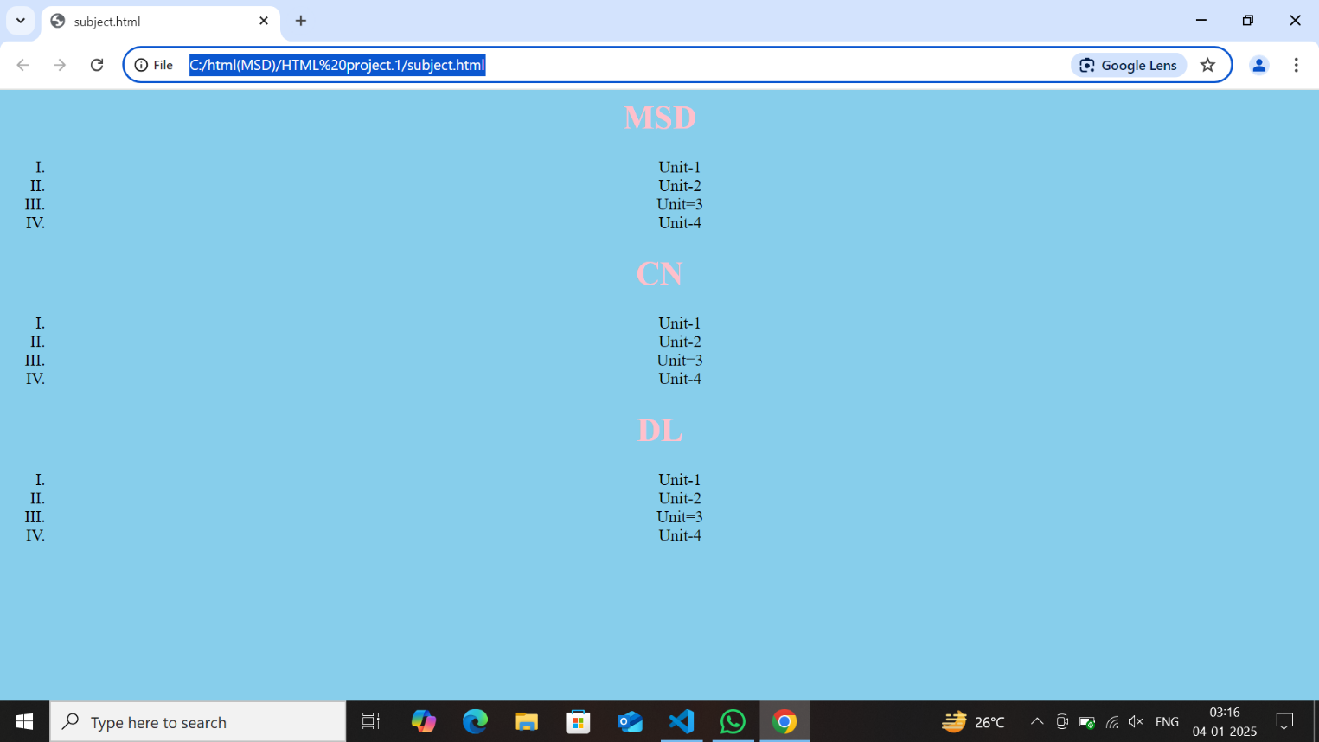

Faculty.html:-

<html>
<head>
<style>
body{
background-color: pink;
color: blue;
}
</style>
</head>
<center>
<body>
<h1>MSD:VINOD SIR</h1>
<h1>CN:CHANDRASEKAR SIR</h1>
<h1>DAA:SUDHAKAR SIR</h1>
<h1>BDA:VIJAYALAKSHMI MAM</h1>
</body>
</center>
</html>

OUTPUT:-
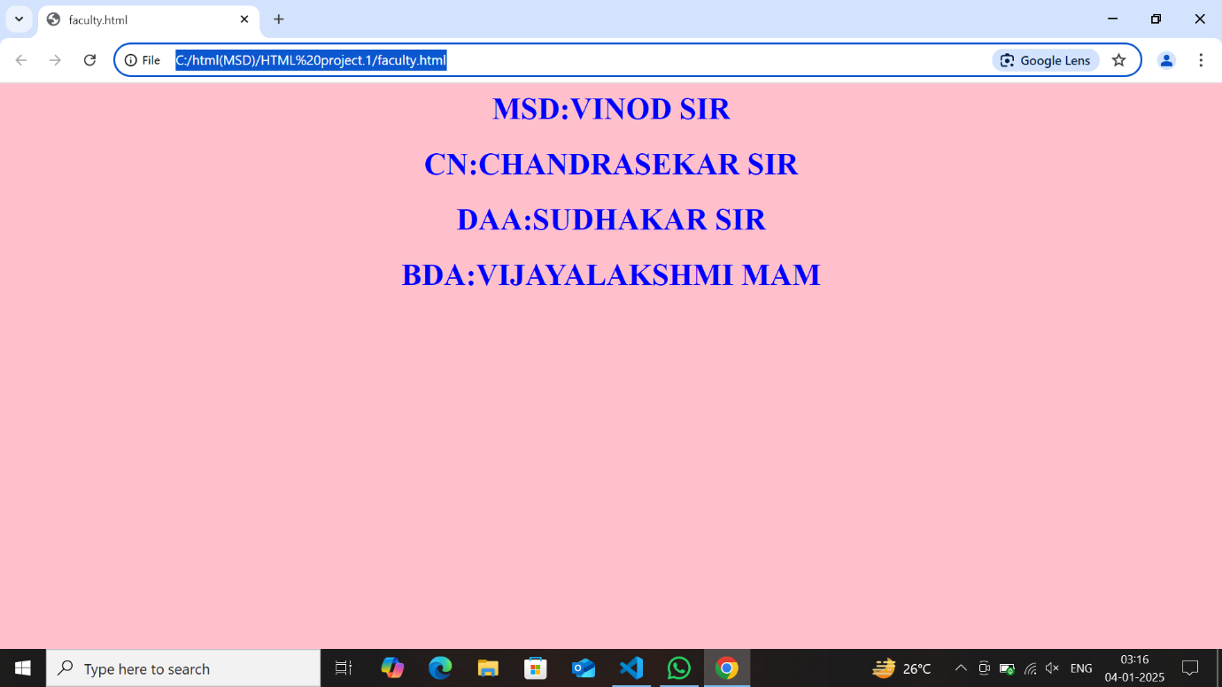

Examsheet.html:-
<html>
<head>
<style>
body{
background-color: violet;
}
</style>
</head>
<center>
<body>
<h1>Mid-1</h1>
<table border="2">
<tr>
<th>s.no</th>
<th>subject</th>
<th>marks</th>
</tr>
<tr>
<td>1</td>
<td>MSD</td>
<td>98</td>
</tr>
<tr>
<td>2</td>
<td>CN</td>
<td>97</td>
</tr>
<tr>
<td>3</td>
<td>DL</td>
<td>95</td>
</tr>
</table>
<br>
<br>
<h1>Mid-2</h1>
<table border="2">
<tr>
<th><s.no</th>
<th>subject</th>
<th>marks</th>
</tr>
<tr>
<td>1</td>
<td>MSD</td>
<td>99</td>
</tr>
<tr>
<td>2</td>
<td>CN</td>
<td>98</td>
</tr>
<tr>
<td>3</td>
<td>DL</td>
<td>96</td>
</tr>
</table>
</body>
</center>
</html>

OUTPUT:-
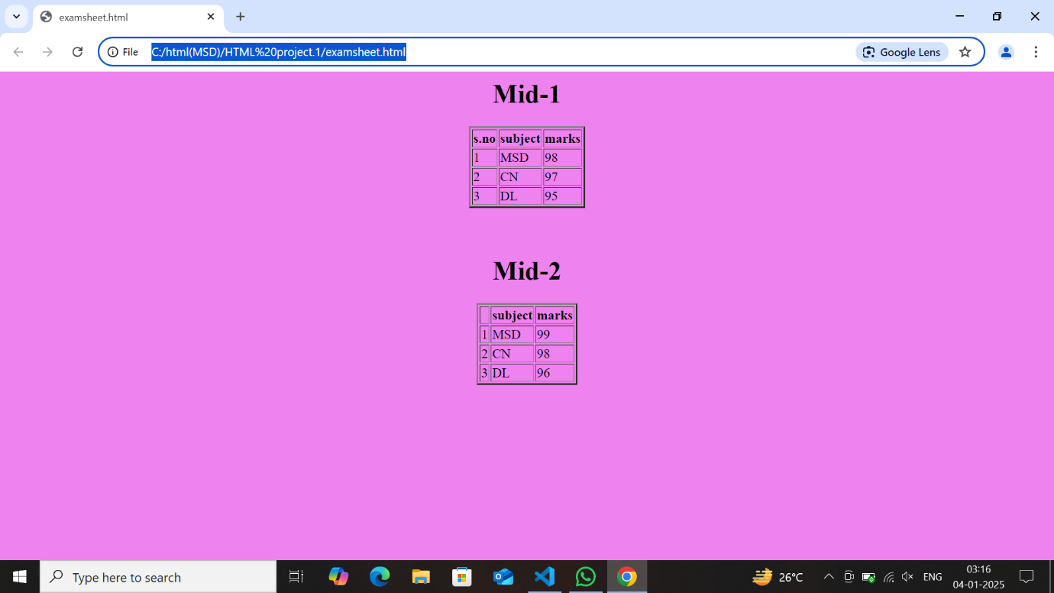

Login.html:-
<html>
<head>
<style>
body{
background-color: black;
color: white;
}
</style>
</head>
<center>
<body>
<label><b>enter your mail:</b></label>
<input type="text" name="fname">
<br>
<br>
<label><b>enter password</b></label>
<input type="text" name="fname">
<br>
<br>
<input type="submit" value="submit">
</body>
</center>
</html>
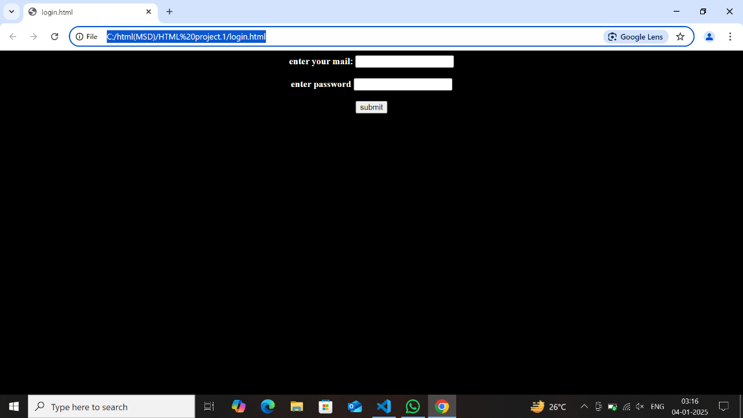
OUTPUT:-

Register.html:-
<html>
<head>
<style>
body{
background-color: aliceblue;
color: pink;
}
</style>
</head>
<center>
<body>
<label>first name:</label>
<input type="text" name="fname">
<br>
<br>
<label>middle name:</label>
<input type="text" name="fname">
<br>
<br>
<label>last name:</label>
<input type="text" name="fname">
<br>
<br>
<label>email:</label>
<input type="text" name="fname">
<br>
<br>
<label>mobile:</label>
<input type="text" name="fname">
<br>
<br>
<input type="submit" value="submit">
</body>
</center>
</html>

OUTPUT:-
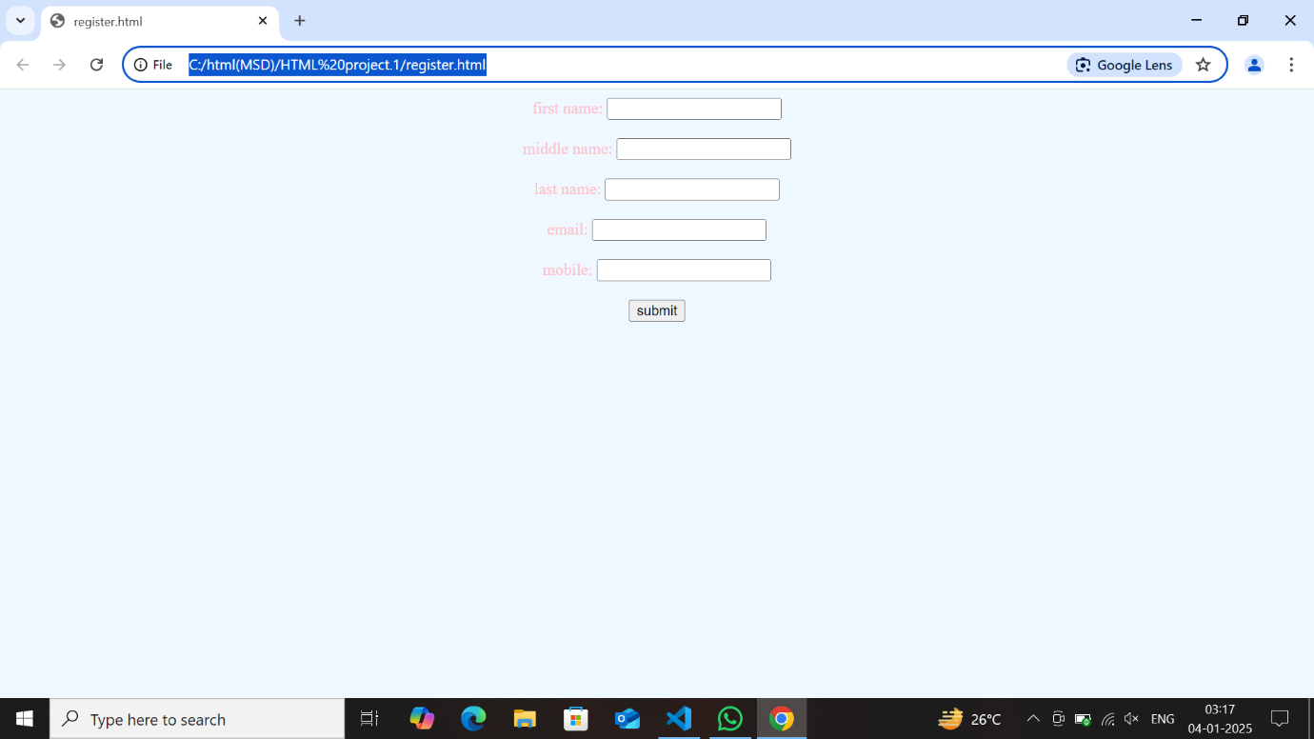

About AI&DS.html:-
<html>
<head>
<style>
body{
background-color: aqua;
color: brown;
}
</style>
</head>
<center>
<body>
<h1>AI-DS</h1>
<p>Artificial Intelligence and Data Science</p>
</body>
</center>
</html>
OUTPUT:-
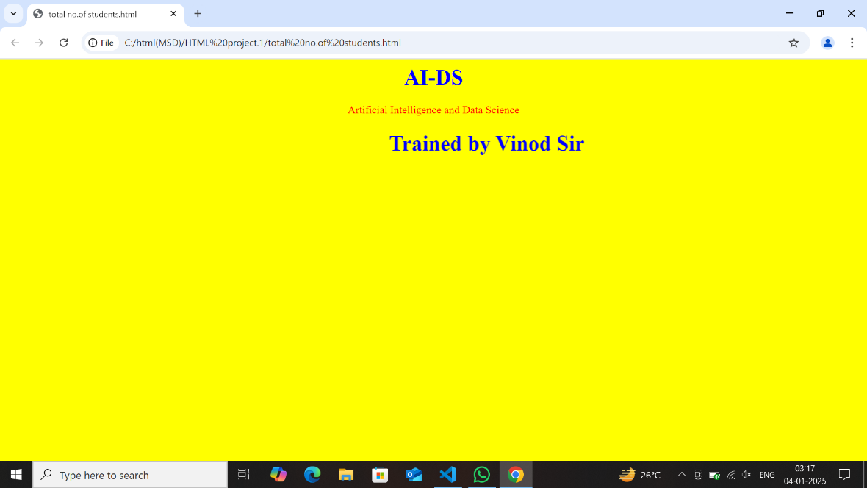

Magazine.html:-
<html>
<head>
<style>
body{
background-color: yellow;
}
div{
width: 150px;
}
</style>
</head>
<body>
<section>
<center>
<h1>IN MNC COMPANY</h1>
<div style="background-color: blue;">
<h1>Placements</h1>
<h2>300+</h2>
</div>
<div style="background-color: green;">
<h1>package</h1>
<h2>4-5lakhs</h2>
</div>
<div style="background-color: red;">
<h1>Aggrement</h1>
<h2>3 years</h2>
</div>
</center>
</section>
</body>
</html>
OUTPUT:-
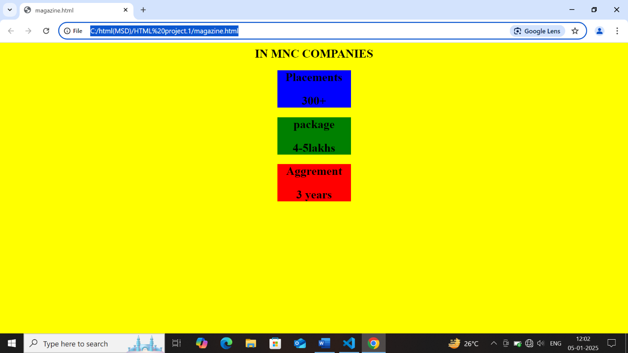

Training.html:-
<html>
<head>
<style>
body{
background-color: black;
color: aliceblue;
}
figure img{
width: 50%;
}
</style>
</head>
<center>
<body>
<h1>Trained By Vinod Sir</h1>
<br>
<figure>
<img src="vinodsir.jpg">
</figure>
</body>
</center>
</html>
OUTPUT:-
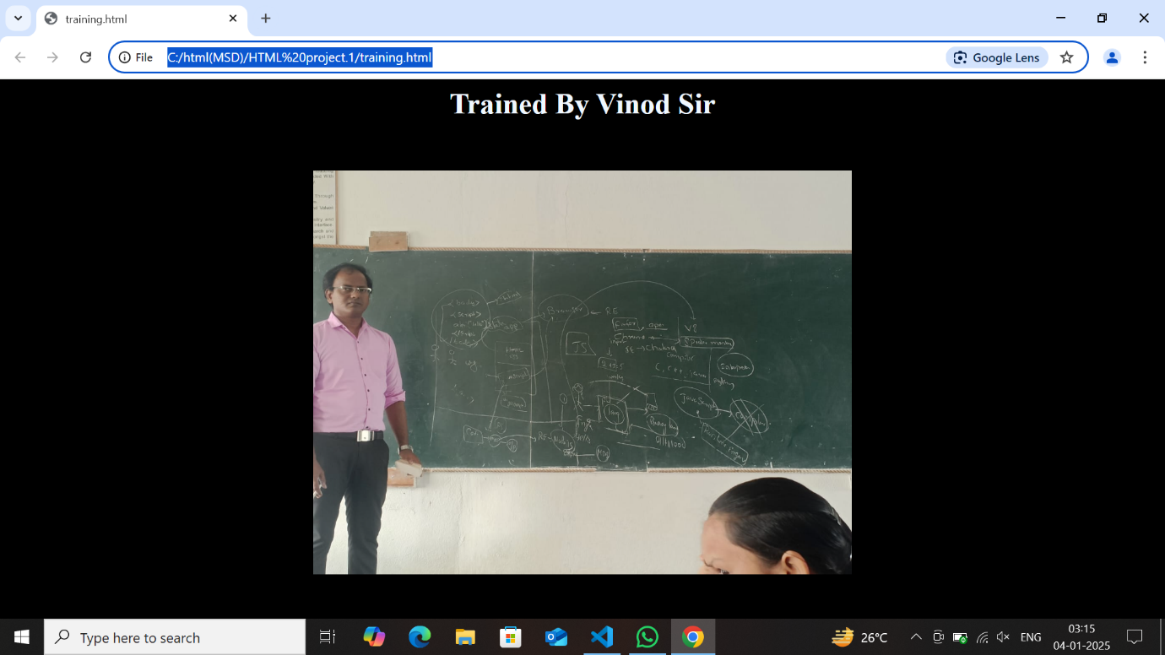

Gallery.html:-
<html>
<head>
<style>
body{
background-color: hotpink;
}
figure{
display:block;
}
</style>
</head>
<body>
<h1>Trained By Vinod Sir</h1>
<center>
<figure>
<img src="vinodsir.jpg" width="40%">
<br>
<br>
<img src="kavya.jpg" width="10%">
<br>
<img src="manju.jpg" width="10%">
<br>
<img src="haripriya.jpg" width="10%">
</figure>
</center>
</body>
</html>

OUTPUT:-

